**Testing Document**

**Tested in BP** - **SUPA00007**

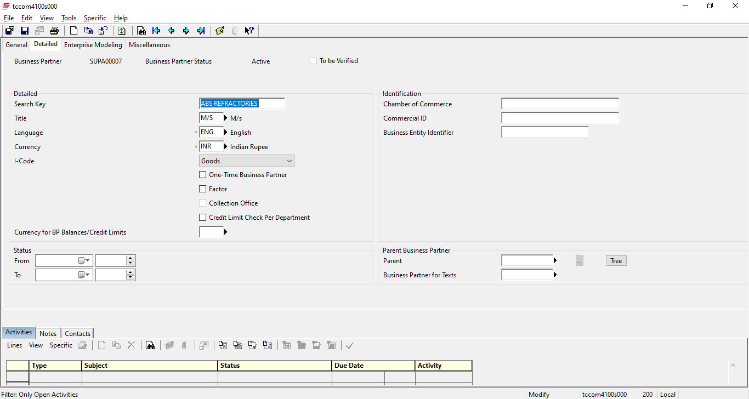

When I update status from date, error occurs.

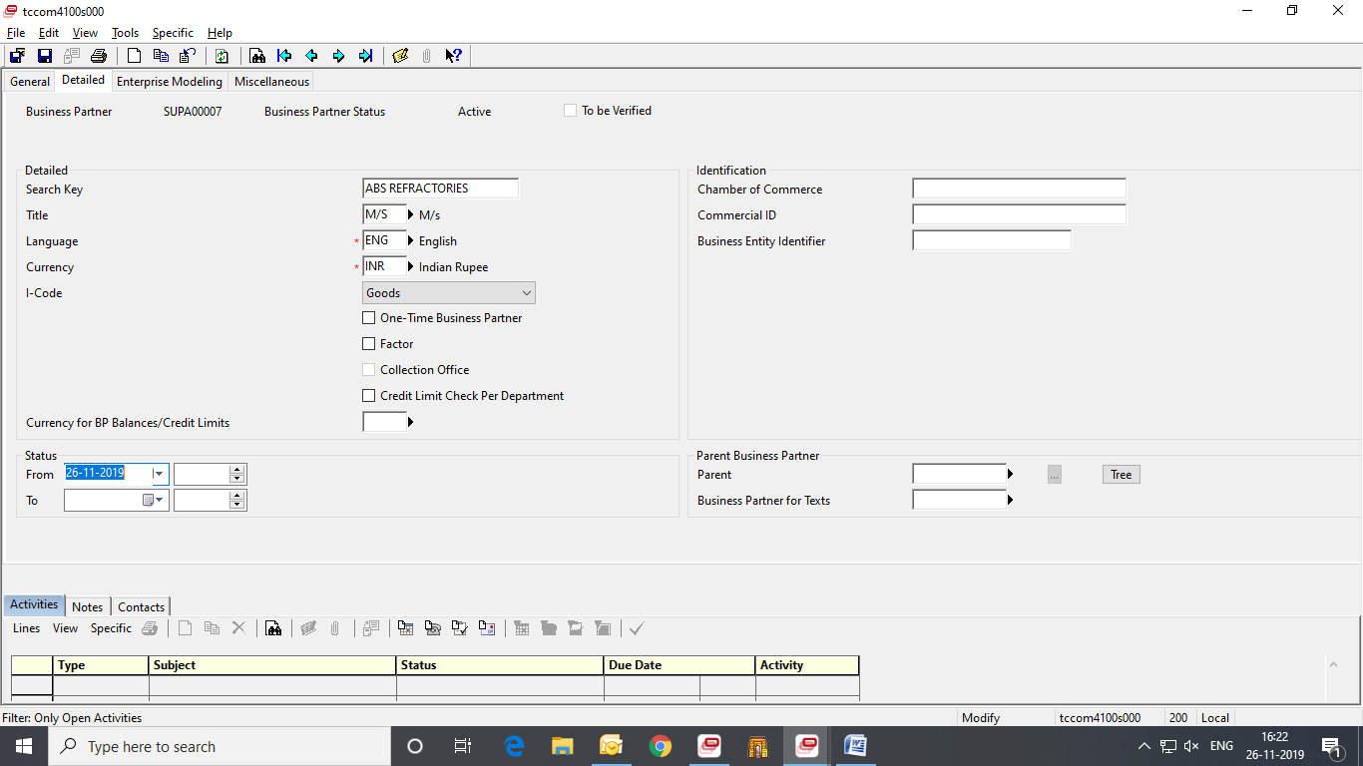

Error occurs:

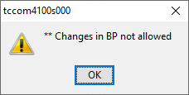

Result : OK